|  |  |  |
| --- | --- | --- |
| logo1 | Nitte Meenakshi Institute of Technology  (AN AUTONOMOUS INSTITUTION, AFFILIATED TO VISVESVARAYA TECHNOLOGICAL UNIVERSITY, BELGAUM) , (A Unit of Nitte Education Trust, Mangalore)  PB No. 6429, Yelahanka, Bangalore 560-064, Karnataka  Telephone: 080- 22167860, Fax: 080 – 22167805  Department of Computer Science and Engineering |  |

Date: 12-11-2017

ANDROID LABORATORY - PROGRAMS

Code: 14CSL77

**PART – A**

1. In this lab we will be learning how to use and extend the Android user interface library.
   1. Views, View Groups, Layouts, and Widgets are and how they relate to each other.
   2. How to declare and reference resources in code.
   3. How to navigate between multiple activities.
   4. How to share the data between the activities.
   5. Explore life-cycle methods of an activity.
   6. How to use Events and Event Listeners.
   7. How to create Toast Notifications.
2. You will expand on your knowledge of the Android user interface library.
   1. How to declare layouts statically as an xml resource.
   2. How to create custom Views from scratch to suit a specific need.
   3. How to create Options and Context Menus.
   4. How to use ListAdapter and ArrayAdapter to bind data source to a List View.
   5. How to create AlertDialog and progress Dialog in your activity.
3. You will be persisting data using an SQLite Database and preserving the state of an application during its lifecycle.
   1. How to save & restore data as Application Preferences (Shared Preference).
   2. How to save & restore data as Instance State.
   3. How to create and manage an SQLiteDatabase in Android.
   4. How to insert, update, remove, and retrieve data from an SQLite Database.
   5. Display data using RecyclerView.
4. Develop an app to capture a photo and store it into SDCard, extend this app to display all the photos capture in the grid view.
   1. How to use the Camera.
   2. How to write data to the SD card.
5. Create an application to demonstrate few key features of the Android framework. In particular, the application demonstrates how to send SMS text messages.
   1. How to send SMS text messages.
   2. How to dial using an in-built dialer
   3. How to send email.
6. Develop an app that include broadcast Receiver to receive the miss calls from the Known number and display it to the user using notification services. This same app should also fetch phone number from the inbuilt contacts using the concept of content provider.
   1. How to use broadcast receiver and notifications.
   2. How to use content providers.
7. Design an android app to fetch the JSON data from the internet and display the data using listView.
   1. Employee data is stored in the internet. (use Async Task)
   2. When app sends the request to the server, the server should provide data in json format.
   3. The client app should fetch this data and display using listview.
8. Develop an android app on Google Map, and should provide following functions.
   1. How to incorporate Google Maps into an application.
   2. How to register for and receive GPS location information.
   3. How to create Google Maps Overlays.
   4. Accept city name from user and marks it on map.
   5. Explore features like Zoom and map types.

**PART – B**

Students should develop an innovative android app project on the societal sector, college activities, transportation, tourist system, medical application, online ticket booking and bill payment,banking sector, recruitment process, etc. Which includes the features that implemented above in Part- A.

**Rubrics for the project includes :**

Implementing the above features of Part-A in project -- 10 marks

Innovative features added to the project by your team -- 5 marks

Presenting the project explaining all features -- 5 marks

Usefull Links

<http://www.json2pojo.com/>

<http://www.jsonschema2pojo.org/>

<https://github.com/loopj/android-async-http/issues/939>

<https://github.com/codepath/android_guides/wiki/Using-a-BaseAdapter-with-ListView>

<http://gradleplease.appspot.com/#gson%20google>

<https://api.open.fec.gov/swagger/>

http://jsonviewer.stack.hu

1. **In this lab we will be learning how to use and extend the Android user interface library.**
   1. **Views, View Groups, Layouts, and Widgets are and how they relate to each other.**
   2. **How to declare and reference resources in code.**
   3. **How to navigate between multiple activities.**
   4. **How to share the data between the activities.**
   5. **Explore life-cycle methods of an activity.**
   6. **How to use Events and Event Listeners.**
   7. **How to create Toast Notifications.**

**Event Handling, Passing Data using Intent and Toast**

MainActivity.java

**et1**= (EditText) findViewById(R.id.***pt***);  
**b1**= (Button) findViewById(R.id.***button2***);  
**b1**.setOnClickListener(**new** View.OnClickListener() {  
 @Override  
 **public void** onClick(View v) {  
  
 Intent i1=**new** Intent(MainActivity.**this**,SecondAct.**class**);  
 i1.putExtra(*msg*,**et1**.getText().toString());  
 startActivity(i1);  
 }  
});

SecondActivity.java

Intent i2=getIntent();  
 Bundle b=i2.getExtras();  
 Toast.*makeText*(**this**, **"In Second Activity"**+b.getString(MainActivity.*msg*), Toast.***LENGTH_SHORT***).show();  
}

1. **You will epand on your knowledge of the Android user interface library.**
   1. **How to declare layouts statically as an xml resource.**
   2. **How to create custom Views from scratch to suit a specific need.**
   3. **How to create Options and Context Menus.**
   4. **How to use ListAdapter and ArrayAdapter to bind data source to a List View.**
   5. **How to create AlertDialog and progress Dialog in your activity.**

**Option Menu**

Step 1:

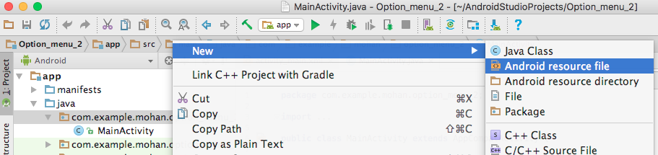

Step 2: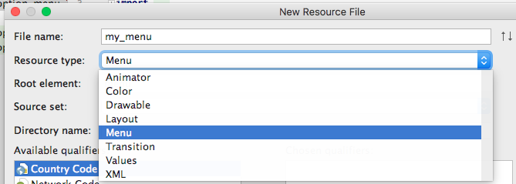

Step 3:

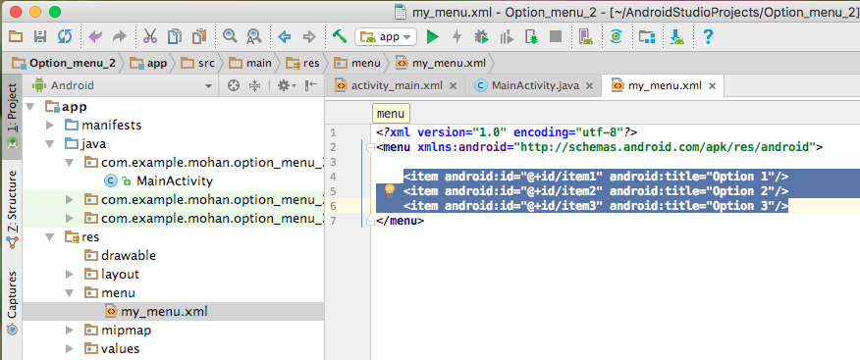

Step 4: 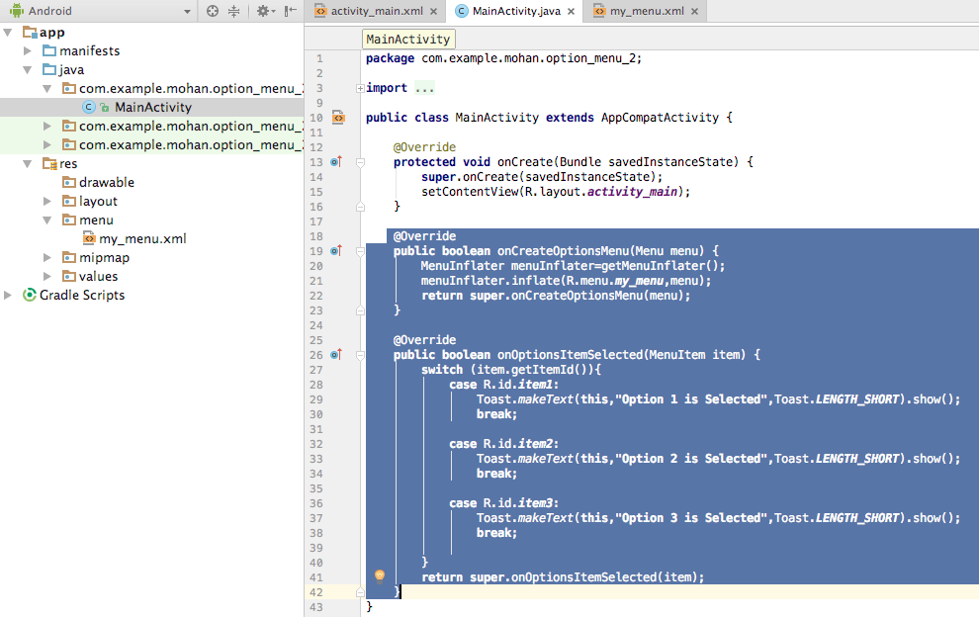

Step 5:

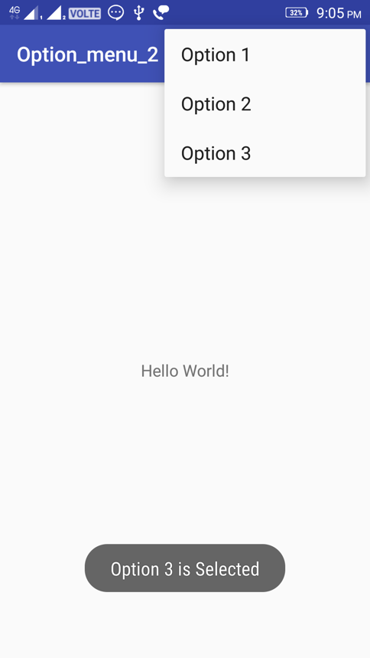

**Context Menu**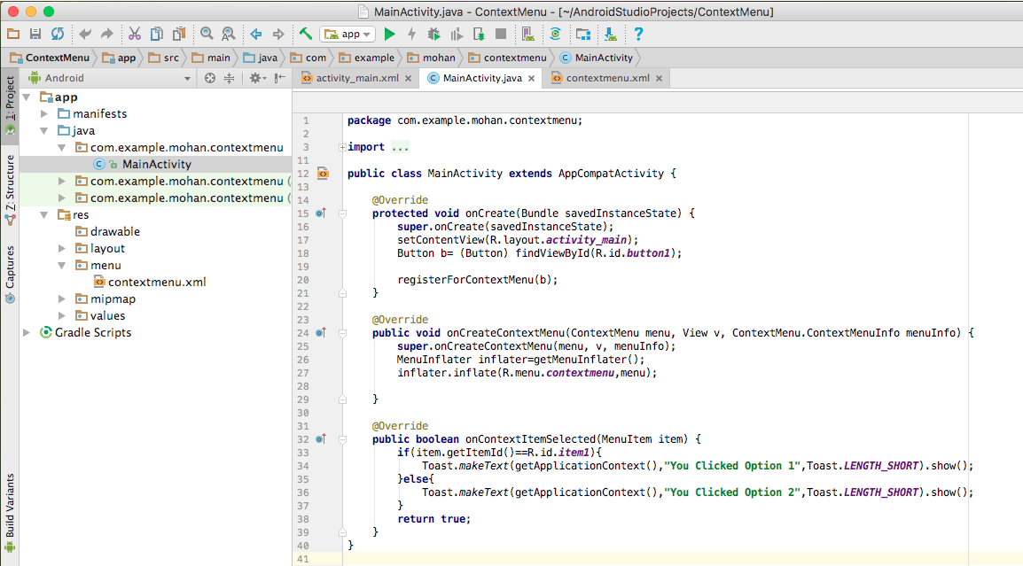

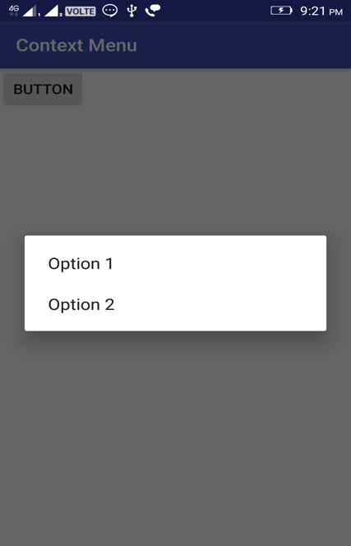

**Program on AlertDialog**

**public class** MainActivity **extends** AppCompatActivity {  
  
 @Override  
 **protected void** onCreate(Bundle savedInstanceState) {  
 **super**.onCreate(savedInstanceState);  
 setContentView(R.layout.***activity_main***);  
 }  
  
 **public void** onClickShowAlert(View view) {  
 AlertDialog.Builder myAlertBuilder=**new** AlertDialog.Builder(MainActivity.**this**);  
 myAlertBuilder.setTitle(R.string.***alert_title***);  
 myAlertBuilder.setMessage(R.string.***alert_message***);  
 myAlertBuilder.setPositiveButton(R.string.***ok***, **new** DialogInterface.OnClickListener() {  
 @Override  
 **public void** onClick(DialogInterface dialog, **int** which) {  
 MainActivity.**this**.finish();}  
 });  
 myAlertBuilder.setNegativeButton(R.string.***cancel***, **new** DialogInterface.OnClickListener() {  
 @Override  
 **public void** onClick(DialogInterface dialog, **int** which) {  
dialog.cancel();  
 }  
 });  
 AlertDialog alert=myAlertBuilder.create();  
 alert.show();  
 }  
}

1. **You will be persisting data using an SQLite Database and preserving the state of an application during its lifecycle.**
   1. **How to save & restore data as Application Preferences (Shared Preference).**
   2. **How to save & restore data as Instance State.**
   3. **How to create and manage an SQLiteDatabase in Android.**
   4. **How to insert, update, remove, and retrieve data from an SQLite Database.**
   5. **Display data using RecyclerView.**

**MainActivity.java**

**package** com.example.mohan.dbapp;  
**import** android.app.Notification;  
**import** android.app.NotificationManager;  
**import** android.app.PendingIntent;  
**import** android.content.Intent;  
**import** android.support.v7.app.AppCompatActivity;  
**import** android.os.Bundle;  
**import** android.view.View;  
**import** android.widget.Button;  
**import** android.widget.EditText;  
**import** android.widget.Toast;  
  
**import static** android.os.Build.VERSION_CODES.***M***;  
  
**public class** MainActivity **extends** AppCompatActivity {  
  
 DatabaseHealper **mDatabaseHealper**;  
 **private** Button **btnAdd**, **btnViewData**;  
 **private** EditText **editText**;  
 @Override  
 **protected void** onCreate(Bundle savedInstanceState) {  
 **super**.onCreate(savedInstanceState);  
 setContentView(R.layout.***activity_main***);  
  
 **editText**= (EditText) findViewById(R.id.***editText***);  
 **btnAdd**= (Button) findViewById(R.id.***addbut***);  
 **btnViewData**= (Button) findViewById(R.id.***savebut***);  
 **mDatabaseHealper**=**new** DatabaseHealper(**this**);  
  
 **btnAdd**.setOnClickListener(**new** View.OnClickListener() {  
 @Override  
 **public void** onClick(View v) {  
 String newEntry=**editText**.getText().toString();  
 **if**(**editText**.length() !=0){  
 AddData(newEntry);  
 **editText**.setText(**""**);  
 }**else**{  
 toastMessage(**"Enter Data"**);  
 }  
 }  
 });  
  
  
 **btnViewData**.setOnClickListener(**new** View.OnClickListener() {  
 @Override  
 **public void** onClick(View v) {  
 Intent intent=**new** Intent(MainActivity.**this**,ListDataActivity.**class**);  
 startActivity(intent);  
 }  
 });  
 }  
  
 **public void** AddData(String newEntry){  
 **boolean** insertData=**mDatabaseHealper**.addData(newEntry);  
 **if**(insertData){  
 toastMessage(**"Data Succesfully Inserted"**);  
 }**else**{ toastMessage(**"Something Went Wrong"**); }  
 }  
  
 **private void** toastMessage(String message){  
 Toast.*makeText*(**this**,message,Toast.***LENGTH_SHORT***).show();  
 }  
}

**ListDataActivity.java**

**package** com.example.mohan.dbapp;  
**import** android.database.Cursor;  
**import** android.os.Bundle;  
**import** android.support.annotation.Nullable;  
**import** android.support.v7.app.AppCompatActivity;  
**import** android.util.Log;  
**import** android.widget.ArrayAdapter;  
**import** android.widget.ListAdapter;  
**import** android.widget.ListView;  
**import** android.widget.Toast;  
**import** java.util.ArrayList;  
**import static** android.icu.lang.UCharacter.GraphemeClusterBreak.***L***;**public class** ListDataActivity **extends** AppCompatActivity {  
  
 **private static final** String ***TAG***=**"ListDataActivity"**;  
  
 DatabaseHealper **mDatabaseHelper**;  
 **private** ListView **mlistView**;  
  
 @Override  
 **protected void** onCreate(@Nullable Bundle savedInstanceState) {  
 **super**.onCreate(savedInstanceState);  
 setContentView(R.layout.***list_layout***);  
 **mlistView**= (ListView) findViewById(R.id.***listView***);  
 **mDatabaseHelper**=**new** DatabaseHealper(**this**);  
 populateListView();  
 }  
  
 **private void** populateListView() {  
 Log.*d*(***TAG***,**"Populate ListView: Displaying data in ListView"**);  
  
 Cursor data=**mDatabaseHelper**.getData();  
 ArrayList<String> listData=**new** ArrayList<>();  
 **while**(data.moveToNext()){  
 listData.add(data.getString(1));  
 }  
 ListAdapter adapter=**new** ArrayAdapter<>(**this**,android.R.layout.***simple_list_item_1***,listData);  
 **mlistView**.setAdapter(adapter);  
 }  
  
 **private void** toastMessage(String message){  
 Toast.*makeText*(**this**,message,Toast.***LENGTH_SHORT***).show();  
 }  
}

**DatabaseHealper.java**

**package** com.example.mohan.dbapp;  
**import** android.content.ContentValues;  
**import** android.content.Context;  
**import** android.database.Cursor;  
**import** android.database.sqlite.SQLiteDatabase;  
**import** android.database.sqlite.SQLiteOpenHelper;  
**import** android.util.Log;  
**import static** android.R.attr.***publicKey***;  
**import static** android.R.attr.***version***;**public class** DatabaseHealper **extends** SQLiteOpenHelper {  
 **private static final** String ***TAG***=**"DatabaseHealper"**;  
 **private static final** String ***TABLE_NAME*** = **"employees"**;  
 **private static final** String ***COL1***=**"ID"**;  
 **private static final** String COL2=**"name"**;  
  
 **public** DatabaseHealper(Context context){ *//}, String name, SQLiteDatabase.CursorFactory factory, int version) {* **super**(context, ***TABLE_NAME***, **null**, 1);  
 }  
  
 @Override  
 **public void** onCreate(SQLiteDatabase db) {  
 String createTable = **"CREATE TABLE "**+***TABLE_NAME*** +**" (ID INTEGER PRIMARY KEY AUTOINCREMENT,"**+COL2+**" TEXT)"**;  
 db.execSQL(createTable);  
 }  
  
 @Override  
 **public void** onUpgrade(SQLiteDatabase db, **int** oldVersion, **int** newVersion) {  
 }  
  
 **public boolean** addData(String item){  
 SQLiteDatabase db=**this**.getWritableDatabase();  
 ContentValues contentValues=**new** ContentValues();  
 contentValues.put(COL2,item);  
 Log.*d*(***TAG***,**"addData: Adding "**+item+**" to "**+***TABLE_NAME***);  
 Long result=db.insert(***TABLE_NAME***,**null**,contentValues);  
 **if**(result == -1) {  
 **return false**;  
 }**else**{  
 **return true**;  
 }  
 }  
 **public** Cursor getData(){  
 SQLiteDatabase db=**this**.getWritableDatabase();  
 String query=**"SELECT * FROM "**+***TABLE_NAME***;  
 Cursor data=db.rawQuery(query,**null**);  
 **return** data;  
 }  
  
}

**Activity_mail.xml**

*<?***xml version="1.0" encoding="utf-8"***?>*<**RelativeLayout xmlns:android="http://schemas.android.com/apk/res/android"  
 xmlns:app="http://schemas.android.com/apk/res-auto"  
 xmlns:tools="http://schemas.android.com/tools"  
 android:layout_width="match_parent"  
 android:layout_height="match_parent"  
 tools:context="com.example.mohan.dbapp.MainActivity"**>  
  
 <**RelativeLayout  
 android:layout_width="match_parent"  
 android:layout_height="match_parent"  
 android:layout_alignParentLeft="true"  
 android:layout_alignParentStart="true"  
 android:layout_marginTop="34dp"**>  
  
 <**Button  
 android:id="@+id/addbut"  
 android:layout_width="wrap_content"  
 android:layout_height="wrap_content"  
 android:text="ADD"  
 tools:layout_editor_absoluteX="140dp"  
 tools:layout_editor_absoluteY="185dp"** />  
  
 <**Button  
 android:id="@+id/savebut"  
 android:layout_width="wrap_content"  
 android:layout_height="wrap_content"  
 android:layout_alignBottom="@+id/addbut"  
 android:layout_marginLeft="21dp"  
 android:layout_marginStart="21dp"  
 android:layout_toEndOf="@+id/addbut"  
 android:layout_toRightOf="@+id/addbut"  
 android:text="VIEW DATA"** />  
 </**RelativeLayout**>  
  
 <**EditText  
 android:id="@+id/editText"  
 android:layout_width="wrap_content"  
 android:layout_height="wrap_content"  
 android:layout_alignParentLeft="true"  
 android:layout_alignParentStart="true"  
 android:layout_alignParentTop="true"  
 android:layout_marginLeft="17dp"  
 android:layout_marginStart="17dp"  
 android:ems="10"  
 android:inputType="textPersonName"  
 android:text="Name"** />  
</**RelativeLayout**>

**list_layout.xml**

*<?***xml version="1.0" encoding="utf-8"***?>*<**LinearLayout xmlns:android="http://schemas.android.com/apk/res/android"  
 android:orientation="vertical" android:layout_width="match_parent"  
 android:layout_height="match_parent"**>  
  
 <**ListView  
 android:layout_width="match_parent"  
 android:layout_height="match_parent"  
 android:id="@+id/listView"** />  
</**LinearLayout**>

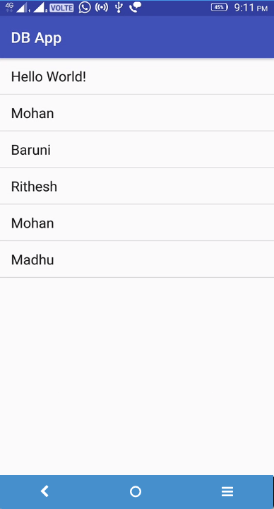

1. **Develop an app to capture a photo and store it into SDCard, extend this app to display all the photos capture in the grid view.**
   1. **How to use the Camera.**
   2. **How to write data to the SD card.**

**CustomAdapter**

**package** nmit.mohan.com.camerasdcard;  
**import** android.content.Intent;  
**import** android.graphics.Bitmap;  
**import** android.net.Uri;  
**import** android.os.Environment;  
**import** android.provider.MediaStore;  
**import** android.support.v7.app.AppCompatActivity;  
**import** android.os.Bundle;  
**import** android.view.View;  
**import** android.widget.Button;a  
**import** android.widget.ImageView;  
  
**import** java.io.File;  
**import** java.text.SimpleDateFormat;  
**import** java.util.Date;  
  
**public class** MainActivity **extends** AppCompatActivity {  
 **final** Integer **CAMERA_REQUEST**=1;  
 ImageView **imageView**;  
 Button **take**,**view**;  
  
 @Override  
 **protected void** onCreate(Bundle savedInstanceState) {  
 **super**.onCreate(savedInstanceState);  
 setContentView(R.layout.***activity_main***);  
 **imageView**= (ImageView) findViewById(R.id.***iv***);  
 **take**= (Button) findViewById(R.id.***takePic***);  
 **view**= (Button) findViewById(R.id.***viewPic***);  
  
 **take**.setOnClickListener(**new** View.OnClickListener() {  
 @Override  
 **public void** onClick(View v) {  
 Intent intent=**new** Intent(MediaStore.***ACTION_IMAGE_CAPTURE***);  
 File pictureDirectory = Environment.*getExternalStoragePublicDirectory*(Environment.*DIRECTORY_MOVIES*);  
 String PictureName=getPictureName();  
 File imageFile=**new** File (pictureDirectory,PictureName);  
 Uri pictureUri=Uri.*fromFile*(imageFile);  
 intent.putExtra(MediaStore.***EXTRA_OUTPUT***,pictureUri);  
 startActivityForResult(intent,**CAMERA_REQUEST**);  
 }  
 });  
 **view**.setOnClickListener(**new** View.OnClickListener() {  
 @Override  
 **public void** onClick(View v) {  
 Intent i=**new** Intent(MainActivity.**this**,Second.**class**);  
 startActivity(i);  
 }  
 });  
 }  
  
 **private** String getPictureName() {  
 SimpleDateFormat sdf=**new** SimpleDateFormat(**"yyyyMMdd_HHmmss"**);  
 String timestamp=sdf.format(**new** Date());  
 **return "IMG"**+timestamp+**".jpg"**;  
 }  
  
 @Override  
 **protected void** onActivityResult(**int** requestCode, **int** resultCode, Intent data) {  
 **super**.onActivityResult(requestCode, resultCode, data);  
 **if**(resultCode==***RESULT_OK***){  
 **if**(requestCode==**CAMERA_REQUEST**){  
*// Bitmap img=(Bitmap) data.getExtras().get("data");  
// imageView.setImageBitmap(img);* }  
 }  
 }  
}

ImageModel.java

**package** nmit.mohan.com.camerasdcard;  
**import** android.net.Uri;  
**public class** ImageModel {  
 **private** String **name**;  
 **private** Uri **uri**;  
 **public** String getName() {  
 **return name**;  
 }  
  
 **public void** setName(String name) {  
 **this**.**name** = name;  
 }  
  
 **public** Uri getUri() {  
 **return uri**;  
 }  
  
 **public void** setUri(Uri uri) {  
 **this**.**uri** = uri;  
 }  
}

MainActivity.java

**package** nmit.mohan.com.camerasdcard;  
**import** android.content.Intent;  
**import** android.graphics.Bitmap;  
**import** android.net.Uri;  
**import** android.os.Environment;  
**import** android.provider.MediaStore;  
**import** android.support.v7.app.AppCompatActivity;  
**import** android.os.Bundle;  
**import** android.view.View;  
**import** android.widget.Button;a  
**import** android.widget.ImageView;  
**import** java.io.File;  
**import** java.text.SimpleDateFormat;  
**import** java.util.Date;  
  
**public class** MainActivity **extends** AppCompatActivity {  
 **final** Integer **CAMERA_REQUEST**=1;  
 ImageView **imageView**;  
 Button **take**,**view**;  
  
 @Override  
 **protected void** onCreate(Bundle savedInstanceState) {  
 **super**.onCreate(savedInstanceState);  
 setContentView(R.layout.***activity_main***);  
 **imageView**= (ImageView) findViewById(R.id.***iv***);  
 **take**= (Button) findViewById(R.id.***takePic***);  
 **view**= (Button) findViewById(R.id.***viewPic***);  
  
 **take**.setOnClickListener(**new** View.OnClickListener() {  
 @Override  
 **public void** onClick(View v) {  
 Intent intent=**new** Intent(MediaStore.***ACTION_IMAGE_CAPTURE***);  
 File pictureDirectory = Environment.*getExternalStoragePublicDirectory*(Environment.*DIRECTORY_MOVIES*);  
 String PictureName=getPictureName();  
 File imageFile=**new** File (pictureDirectory,PictureName);  
 Uri pictureUri=Uri.*fromFile*(imageFile);  
 intent.putExtra(MediaStore.***EXTRA_OUTPUT***,pictureUri);  
 startActivityForResult(intent,**CAMERA_REQUEST**);  
 }  
 });  
 **view**.setOnClickListener(**new** View.OnClickListener() {  
 @Override  
 **public void** onClick(View v) {  
 Intent i=**new** Intent(MainActivity.**this**,Second.**class**);  
 startActivity(i);  
 }  
 });  
 }  
  
 **private** String getPictureName() {  
 SimpleDateFormat sdf=**new** SimpleDateFormat(**"yyyyMMdd_HHmmss"**);  
 String timestamp=sdf.format(**new** Date());  
 **return "IMG"**+timestamp+**".jpg"**;  
 }  
  
 @Override  
 **protected void** onActivityResult(**int** requestCode, **int** resultCode, Intent data) {  
 **super**.onActivityResult(requestCode, resultCode, data);  
 **if**(resultCode==***RESULT_OK***){  
 **if**(requestCode==**CAMERA_REQUEST**){  
*// Bitmap img=(Bitmap) data.getExtras().get("data");  
// imageView.setImageBitmap(img);* }  
 }  
 }  
}

**Second Activity.java**

**package** nmit.mohan.com.camerasdcard;  
**import** android.net.Uri;  
**import** android.os.Environment;  
**import** android.support.v7.app.AppCompatActivity;  
**import** android.os.Bundle;  
**import** android.widget.GridView;  
**import** java.io.File;  
**import** java.util.ArrayList;  
  
**public class** Second **extends** AppCompatActivity {  
  
 @Override  
 **protected void** onCreate(Bundle savedInstanceState) {  
 **super**.onCreate(savedInstanceState);  
 setContentView(R.layout.activity_second);  
 **final** GridView gv= (GridView) findViewById(R.id.***gv***);  
  
 gv.setAdapter(**new** CustomAdapter(Second.**this**,getData()));  
 }  
  
 **private** ArrayList<ImageModel> getData(){  
 ArrayList<ImageModel> imgModel=**new** ArrayList<>();  
 File DownloadFolder= Environment.*getExternalStoragePublicDirectory*(Environment.*DIRECTORY_MOVIES*);  
 ImageModel im;  
 **if**(DownloadFolder.exists()){  
 File []files=DownloadFolder.listFiles();  
  
 **for** (**int** i = 0; i < files.**length**; i++) {  
 File file=files[i];  
 im=**new** ImageModel();  
 im.setName(file.getName());  
 im.setUri(Uri.*fromFile*(file));  
 imgModel.add(im);  
 }  
 }  
 **return** imgModel;  
 }  
  
}

**activity_main.xml**

*<?***xml version="1.0" encoding="utf-8"***?>*<**LinearLayout xmlns:android="http://schemas.android.com/apk/res/android"  
 xmlns:app="http://schemas.android.com/apk/res-auto"  
 xmlns:tools="http://schemas.android.com/tools"  
 android:layout_width="match_parent"  
 android:orientation="vertical"  
 android:layout_height="match_parent"  
 tools:context="nmit.mohan.com.camerasdcard.MainActivity"**>  
  
 <**TextView  
 android:layout_width="wrap_content"  
 android:layout_height="wrap_content"  
 android:text="Hello World!"  
 app:layout_constraintBottom_toBottomOf="parent"  
 app:layout_constraintLeft_toLeftOf="parent"  
 app:layout_constraintRight_toRightOf="parent"  
 app:layout_constraintTop_toTopOf="parent"** />  
  
<**ImageView  
 android:layout_width="match_parent"  
 android:layout_height="451dp"  
 android:id="@+id/iv"**/>  
<**Button  
 android:layout_width="wrap_content"  
 android:layout_height="wrap_content"  
 android:id="@+id/takePic"  
 android:text="Take Pic"** />  
 <**Button  
 android:layout_width="wrap_content"  
 android:layout_height="wrap_content"  
 android:id="@+id/viewPic"  
 android:text="Gallery"** />  
</**LinearLayout**>

**activity_second.xml**

*<?***xml version="1.0" encoding="utf-8"***?>*<**RelativeLayout xmlns:android="http://schemas.android.com/apk/res/android"  
 xmlns:app="http://schemas.android.com/apk/res-auto"  
 xmlns:tools="http://schemas.android.com/tools"  
 android:layout_width="match_parent"  
 android:layout_height="match_parent"  
 tools:context="nmit.mohan.com.camerasdcard.Second"**>  
  
 <**GridView  
 android:layout_width="match_parent"  
 android:layout_height="match_parent"  
 android:numColumns="2"  
 android:id="@+id/gv"**>  
 </**GridView**>  
</**RelativeLayout**>

**Itemlayout.xml**

*<?***xml version="1.0" encoding="utf-8"***?>*<**LinearLayout xmlns:android="http://schemas.android.com/apk/res/android"  
 xmlns:app="http://schemas.android.com/apk/res-auto"  
 android:orientation="vertical" android:layout_width="wrap_content"  
 android:layout_height="wrap_content"**>  
  
 <**TextView  
 android:layout_width="wrap_content"  
 android:layout_height="wrap_content"  
 android:id="@+id/itemtv"  
 android:text="some text"** />  
  
 <**ImageView  
 android:id="@+id/itemiv"  
 android:layout_width="135dp"  
 android:layout_height="160dp"  
 app:srcCompat="@drawable/cameraicon"** />  
</**LinearLayout**>

1. **Create an application to demonstrate few key features of the Android framework. In particular, the application demonstrates how to send SMS text messages.** 
   1. **How to send SMS text messages.**
   2. **How to dial using an in-built dialer**
   3. **How to send email.**

**MainActivity.java**

**package** nmit.mohan.com.app_sms_email_phone;  
**import** android.Manifest;  
**import** android.content.Intent;  
**import** android.content.pm.PackageManager;  
**import** android.net.Uri;  
**import** android.support.annotation.NonNull;  
**import** android.support.v4.app.ActivityCompat;  
**import** android.support.v4.content.ContextCompat;  
**import** android.support.v7.app.AppCompatActivity;  
**import** android.os.Bundle;  
**import** android.telephony.SmsManager;  
**import** android.view.View;  
**import** android.widget.Button;  
**import** android.widget.EditText;  
**import** android.widget.Toast;  
  
**public class** MainActivity **extends** AppCompatActivity {  
 **private static final int *MY_PERMISSIONS_REQUEST_SEND_SMS*** = 0;  
 Button **sendBtn**;  
 Button **btnSendEmail**;  
 Button **btnPhone**;  
 String **phoneNo**;  
 String **message**;  
  
 @Override  
 **protected void** onCreate(Bundle savedInstanceState) {  
 **super**.onCreate(savedInstanceState);  
 setContentView(R.layout.***activity_main***);  
  
 **sendBtn** = (Button) findViewById(R.id.***btnSendSMS***);  
  
 **btnSendEmail** = (Button) findViewById(R.id.***btnSendEmail***);  
 **btnPhone** = (Button) findViewById(R.id.***btnDialPhone***);  
  
 **sendBtn**.setOnClickListener(**new** View.OnClickListener() {  
 **public void** onClick(View view) {  
 sendSMSMessage();  
 }  
 });  
  
 **btnSendEmail**.setOnClickListener(**new** View.OnClickListener() {  
 @Override  
 **public void** onClick(View v) {  
 sendEmail();  
 }  
 });  
  
 **btnPhone**.setOnClickListener(**new** View.OnClickListener() {  
 @Override  
 **public void** onClick(View v) {  
 PhoneDial();  
 }  
 });  
 }  
  
 **protected void** sendEmail() {  
 Intent emailIntent = **new** Intent(Intent.***ACTION_SEND***);  
 emailIntent.setData(Uri.*parse*(**"mailto:"**));  
 emailIntent.setType(**"text/plain"**);  
 emailIntent.putExtra(Intent.***EXTRA_EMAIL***, **new** String[]{**"ba.mohan@gmail.com"**});  
 emailIntent.putExtra(Intent.***EXTRA_SUBJECT***, **"subject Test"**);  
 emailIntent.putExtra(Intent.***EXTRA_TEXT***, **"Message Body Test"**);  
 startActivity(emailIntent);  
 }  
  
 **protected void** sendSMSMessage() {  
 Intent sendIntent = **new** Intent(Intent.***ACTION_VIEW***);  
 sendIntent.putExtra(**"sms_body"**, **"default content"**);  
 sendIntent.setType(**"vnd.android-dir/mms-sms"**);  
 startActivity(sendIntent);  
 Toast.*makeText*(getApplicationContext(), **"SMS sent."**,  
 Toast.***LENGTH_LONG***).show();  
 }  
  
 **protected void** PhoneDial() {  
 Intent intent = **new** Intent(Intent.***ACTION_DIAL***);  
 startActivity(intent); }  
 }

**activity_main.xml**

*<?***xml version="1.0" encoding="utf-8"***?>*<**RelativeLayout xmlns:android="http://schemas.android.com/apk/res/android"  
 xmlns:app="http://schemas.android.com/apk/res-auto"  
 xmlns:tools="http://schemas.android.com/tools"  
 android:layout_width="match_parent"  
 android:layout_height="match_parent"  
 tools:context="nmit.mohan.com.app_sms_email_phone.MainActivity"**>  
 <**TextView  
 android:id="@+id/textView1"  
 android:layout_width="wrap_content"  
 android:layout_height="wrap_content"  
 android:text="Sending SMS Example"  
 android:layout_alignParentTop="true"  
 android:layout_centerHorizontal="true"  
 android:textSize="30dp"** />  
  
 <**Button  
 android:layout_width="wrap_content"  
 android:layout_height="wrap_content"  
 android:text="Send Sms"  
 android:id="@+id/btnSendSMS"  
 android:layout_centerHorizontal="true"  
 android:layout_marginTop="48dp"** />  
  
 <**Button  
 android:layout_width="wrap_content"  
 android:layout_height="wrap_content"  
 android:text="Send Email"  
 android:id="@+id/btnSendEmail"  
 android:layout_below="@+id/btnSendSMS"  
 android:layout_centerHorizontal="true"  
 android:layout_marginTop="48dp"** />  
  
 <**Button  
 android:layout_width="wrap_content"  
 android:layout_height="wrap_content"  
 android:text="Phone"  
 android:id="@+id/btnDialPhone"  
 android:layout_marginTop="54dp"** />  
</**RelativeLayout**>

1. **Develop an app that include broadcast Receiver to receive the miss calls from the Known number and display it to the user using notification services. This same app should also fetch phone number from the inbuilt contacts using the concept of content provider.**
   1. **How to use broadcast receiver and notifications.**
   2. **How to use content providers.**

**App on Notification**

**Activity_mail.xml**

<**Button  
 android:id="@+id/but1"  
 android:layout_width="wrap_content"  
 android:layout_height="wrap_content"  
 android:text="Notify Me"  
 tools:layout_editor_absoluteX="140dp"  
 tools:layout_editor_absoluteY="185dp"  
 android:layout_alignParentLeft="true"  
 android:layout_alignParentStart="true"  
 android:layout_marginTop="22dp"** />

**MainActivity.java**

**public class** MainActivity **extends** AppCompatActivity {  
  
 Button **but**;  
 @Override  
 **protected void** onCreate(Bundle savedInstanceState) {  
 **super**.onCreate(savedInstanceState);  
 setContentView(R.layout.***activity_main***);  
 **but**=(Button) findViewById(R.id.***but1***);  
 **but**.setOnClickListener(**new** View.OnClickListener() {  
 @Override  
 **public void** onClick(View v) {  
 Intent int1=**new** Intent();  
 PendingIntent pi1=PendingIntent.*getActivity*(MainActivity.**this**,0,int1,0);  
 Notification not1=**new** Notification.Builder(MainActivity.**this**)  
 .setTicker(**"Ticker Title"**)  
 .setContentTitle(**"Mohan\'s Notification"**)  
 .setContentText(**"This is Notification Example"**)  
 .setSmallIcon(R.drawable.***icon***)  
 .addAction(R.drawable.***red_button***,**"Action 1"**,pi1)  
 .addAction(R.drawable.***green_ball***,**"Action 2"**,pi1)  
 .setContentIntent(pi1).getNotification();  
 not1.**flags**=Notification.***FLAG_AUTO_CANCEL***;  
 NotificationManager nm= (NotificationManager) getSystemService(***NOTIFICATION_SERVICE***);  
 nm.notify(0,not1);  
 }  
 });  
 }  
}

 

Read Number from Contacts

**AndroidManifest.xml** <**uses-permission android:name="android.permission.READ_CONTACTS"**/

**package** com.example.mohan.retrivingcontacts;  
**import** android.app.Activity;  
**import** android.content.Intent;  
**import** android.database.Cursor;  
**import** android.net.Uri;  
**import** android.provider.ContactsContract;  
**import** android.support.v7.app.AppCompatActivity;  
**import** android.os.Bundle;  
**import** android.view.View;  
**import** android.widget.Button;  
**import** android.widget.Toast;  
  
**public class** MainActivity **extends** AppCompatActivity {  
 @Override  
 **protected void** onCreate(Bundle savedInstanceState) {  
 **super**.onCreate(savedInstanceState);  
 setContentView(R.layout.***activity_main***);  
 Button button = (Button)findViewById(R.id.***button***);  
 button.setOnClickListener(**new** View.OnClickListener()  
 {  
 @Override  
 **public void** onClick(View v)  
 {  
 Intent intent = **new** Intent(Intent.***ACTION_PICK***, ContactsContract.Contacts.***CONTENT_URI***); startActivityForResult(intent, 1);  
 }  
 });  
 }  
  
 @Override **public void** onActivityResult(**int** reqCode, **int** resultCode, Intent data){ **super**.onActivityResult(reqCode, resultCode, data);  
 **switch**(reqCode)  
 {  
 **case** (1):  
 **if** (resultCode == Activity.***RESULT_OK***)  
 {  
 Uri contactData = data.getData();  
 Cursor c = managedQuery(contactData, **null**, **null**, **null**, **null**);  
 **if** (c.moveToFirst())  
 {  
 String id = c.getString(c.getColumnIndexOrThrow(ContactsContract.Contacts.***_ID***));

String hasPhone =c.getString(c.getColumnIndex(ContactsContract.Contacts.***HAS_PHONE_NUMBER***));  
  
 **if** (hasPhone.equalsIgnoreCase(**"1"**))  
 {  
 Cursor phones = getContentResolver().query(ContactsContract.CommonDataKinds.Phone.***CONTENT_URI***,**null**,ContactsContract.CommonDataKinds.Phone.***CONTACT_ID*** +**" = "**+ id,**null**, **null**);  
 phones.moveToFirst();  
String cNumber = phones.getString(phones.getColumnIndex(ContactsContract.CommonDataKinds.Phone.***NUMBER***));  
 Toast.*makeText*(getApplicationContext(), cNumber, Toast.***LENGTH_SHORT***).show();  
 *//setCn(cNumber);* }  
 }  
 }  
 }  
 }  
  
}

 

**7.Design an android app to fetch the JSON data from the internet and display the data using listView.**

* 1. **Employee data is stored in the internet. (use Async Task)**
  2. **When app sends the request to the server, the server should provide data in json format.**
  3. **The client app should fetch this data and display using listview.**

<https://api.androidhive.info/contacts/>

{

"contacts": [

{

"id": "c200",

"name": "Ravi Tamada",

"email": "ravi@gmail.com",

"address": "xx-xx-xxxx,x - street, x - country",

"gender" : "male",

"phone": {

"mobile": "+91 0000000000",

"home": "00 000000",

"office": "00 000000"

}

},

**Main_Activity.java**

**public class** MainActivity **extends** AppCompatActivity {  
 Button **b**;  
 ListView **lv**;  
 ArrayList<HashMap<String, String>> **contactList**;  
  
 @Override  
 **protected void** onCreate(Bundle savedInstanceState) {  
 **super**.onCreate(savedInstanceState);  
 setContentView(R.layout.***activity_main***);  
  
 **contactList** = **new** ArrayList<>();  
 **lv**= (ListView) findViewById(R.id.***list***);  
 **b**= (Button) findViewById(R.id.***fetch***);  
 **b**.setOnClickListener(**new** View.OnClickListener() {  
 @Override  
 **public void** onClick(View v) {  
 String strUrl = **"https://api.androidhive.info/contacts/"**;  
 **new** UrlHandler().execute(strUrl);  
 }  
 });  
 }  
  
 **public class** UrlHandler **extends** AsyncTask<String, Integer, String> {  
 @Override  
 **protected void** onPostExecute(String s) {  
 **super**.onPostExecute(s);  
 ListAdapter adapter = **new** SimpleAdapter(MainActivity.**this**, **contactList**,  
 R.layout.***list_item***, **new** String[]{ **"id"**,**"name"**,**"email"**},  
 **new int**[]{R.id.***cid***,R.id.***cname***, R.id.***cemail***});  
 **lv**.setAdapter(adapter);  
 }  
  
 @Override  
 **protected** String doInBackground(String... params) {  
  
 String json_response = **null**;  
 **try** {  
 URL url = **new** URL(params[0]);  
 HttpURLConnection connection = (HttpURLConnection) url.openConnection();  
 connection.setRequestMethod(**"GET"**);  
 connection.connect();  
 InputStream in = **new** BufferedInputStream(connection.getInputStream());  
 json_response = convertStreamToString(in);  
  
 **if** (json_response != **null**) {  
 **try** {  
 JSONObject jsonObj = **new** JSONObject(json_response);  
  
 *// Getting JSON Array node* JSONArray contacts = jsonObj.getJSONArray(**"contacts"**);  
  
 *// looping through All Contacts* **for** (**int** i = 0; i < contacts.length(); i++) {  
 JSONObject c = contacts.getJSONObject(i);  
 String id = c.getString(**"id"**);  
 String name = c.getString(**"name"**);  
 String email = c.getString(**"email"**);  
  
 *// tmp hash map for single contact* HashMap<String, String> contact = **new** HashMap<>();  
  
 *// adding each child node to HashMap key => value* contact.put(**"id"**, id);  
 contact.put(**"name"**, name);  
 contact.put(**"email"**, email);  
  
 *// adding contact to contact list* **contactList**.add(contact);  
 }  
 } **catch** (JSONException e) {  
 Log.*e*(**"error"**, **"Json parsing error: "** + e.getMessage());  
 }  
 } **else** {  
 Log.*e*(**"error"**, **"Couldn't get json from server."**);  
 }  
 } **catch** (MalformedURLException e) {  
 e.printStackTrace();  
 } **catch** (IOException e) {  
 e.printStackTrace();  
 }  
 **return null**;  
 }  
 **private** String convertStreamToString(InputStream is) {  
 BufferedReader reader = **new** BufferedReader(**new** InputStreamReader(is));  
 StringBuilder sb = **new** StringBuilder();  
  
 String line;  
 **try** {  
 **while** ((line = reader.readLine()) != **null**) {  
 sb.append(line).append(**'\n'**);  
 }  
 } **catch** (IOException e) {  
 e.printStackTrace();  
 }  
 **return** sb.toString();  
 }  
 }  
}

**activity_main.xml**

*<?***xml version="1.0" encoding="utf-8"***?>*<**LinearLayout  
 xmlns:android="http://schemas.android.com/apk/res/android"  
 xmlns:tools="http://schemas.android.com/tools"  
 xmlns:app="http://schemas.android.com/apk/res-auto"  
 android:layout_width="match_parent"  
 android:layout_height="match_parent"  
 android:orientation="vertical"  
 tools:context="nmit.mohan.com.myapplication.MainActivity"**>  
  
 <**Button  
 android:layout_width="match_parent"  
 android:layout_height="wrap_content"  
 android:text="Fetch Data"  
 android:id="@+id/fetch"** />  
  
 <**TextView  
 android:layout_width="match_parent"  
 android:layout_height="wrap_content"  
 android:id="@+id/textView"** />  
 <**ListView  
 android:layout_width="match_parent"  
 android:layout_height="wrap_content"  
 android:id="@+id/list"** ></**ListView**>  
</**LinearLayout**>

**list_item.xml**

*<?***xml version="1.0" encoding="utf-8"***?>*<**LinearLayout xmlns:android="http://schemas.android.com/apk/res/android"  
 android:orientation="vertical" android:layout_width="match_parent"  
 android:layout_height="match_parent"**>  
 <**TextView  
 android:layout_width="match_parent"  
 android:layout_height="wrap_content"  
 android:id="@+id/cid"** />  
 <**TextView  
 android:layout_width="match_parent"  
 android:layout_height="wrap_content"  
 android:id="@+id/cname"** />  
 <**TextView  
 android:layout_width="match_parent"  
 android:layout_height="wrap_content"  
 android:id="@+id/cemail"** />  
</**LinearLayout**>

**Android_Mainfest.xml**

<**uses-permission android:name="android.permission.INTERNET"**></**uses-permission**>

**8.Develop an android app on Google Map, and should provide following functions.**

* 1. **How to incorporate Google Maps into an application.**
  2. **How to register for and receive GPS location information.**
  3. **How to create Google Maps Overlays.**
  4. **Accept city name from user and marks it on map.**
  5. **Explore features like Zoom and map types.**

**MapsActivity.java**

**package** com.example.mohan.demomaps;  
**import** android.Manifest;  
**import** android.content.pm.PackageManager;  
**import** android.location.Address;  
**import** android.location.Geocoder;  
**import** android.support.v4.app.ActivityCompat;  
**import** android.support.v4.app.FragmentActivity;  
**import** android.os.Bundle;  
**import** android.view.View;  
**import** android.widget.EditText;  
**import** android.widget.TextView;  
**import** com.google.android.gms.maps.CameraUpdateFactory;  
**import** com.google.android.gms.maps.GoogleMap;  
**import** com.google.android.gms.maps.OnMapReadyCallback;  
**import** com.google.android.gms.maps.SupportMapFragment;  
**import** com.google.android.gms.maps.model.LatLng;  
**import** com.google.android.gms.maps.model.MarkerOptions;  
**import** java.io.IOException;  
**import** java.util.List;  
  
**public class** MapsActivity **extends** FragmentActivity **implements** OnMapReadyCallback {  
 **private** GoogleMap **mMap**;  
 **private** TextView **tv**;  
  
 @Override  
 **protected void** onCreate(Bundle savedInstanceState) {  
 **super**.onCreate(savedInstanceState);  
 setContentView(R.layout.***activity_maps***);  
 *// Obtain the SupportMapFragment and get notified when the map is ready to be used.* SupportMapFragment mapFragment = (SupportMapFragment) getSupportFragmentManager()  
 .findFragmentById(R.id.***map***);  
 mapFragment.getMapAsync(**this**);  
 }  
  
 @Override  
 **public void** onMapReady(GoogleMap googleMap) {  
 **mMap** = googleMap;  
 *// Add a marker in Sydney and move the camera* LatLng sydney = **new** LatLng(-35, 121.5);  
 **mMap**.addMarker(**new** MarkerOptions().position(sydney).title(**"Marker"**));  
 **mMap**.moveCamera(CameraUpdateFactory.*newLatLng*(sydney));  
 }  
  
 **public void** setmMap(GoogleMap mMap) {  
 **this**.**mMap** = mMap; }  
  
 **public void** onSearch(View view) {  
 List<Address> addressList=**null**;  
 EditText et_location= (EditText) findViewById(R.id.***et1***);  
 String location=et_location.getText().toString();  
 **if**(location!=**null** || location.equals(**""**)){  
 Geocoder geocoder=**new** Geocoder(**this**);  
 **try** {  
 addressList= geocoder.getFromLocationName(location,1);  
 } **catch** (IOException e) { e.printStackTrace(); }  
  
 Address address=addressList.get(0);  
 LatLng latLng=**new** LatLng(address.getLatitude(),address.getLongitude());  
 **mMap**.addMarker(**new** MarkerOptions().position(latLng).title(location));  
 **mMap**.animateCamera(CameraUpdateFactory.*newLatLng*(latLng ));  
 }  
 }  
  
 **public void** onType(View view) {  
 **if**(**mMap**.getMapType()== GoogleMap.***MAP_TYPE_NORMAL***){  
 **mMap**.setMapType(GoogleMap.***MAP_TYPE_SATELLITE***);  
 }**else**{ **mMap**.setMapType(GoogleMap.***MAP_TYPE_NORMAL***); }  
 }  
  
 **public void** onZoom(View view) {  
 **if**(view.getId()==R.id.***zoomin***){  
 **mMap**.animateCamera(CameraUpdateFactory.*zoomIn*());  
 } **if**(view.getId()==R.id.***zoomout***){**mMap**.animateCamera(CameraUpdateFactory.*zoomOut*());  
 }  
 }  
}

**Activity_maps.xml**

*<?***xml version="1.0" encoding="utf-8"***?>*<**RelativeLayout xmlns:android="http://schemas.android.com/apk/res/android"  
 android:layout_width="match_parent"  
 android:orientation="vertical"  
 android:layout_height="400dp"**>  
 <**LinearLayout  
 android:layout_width="wrap_content"  
 android:layout_height="wrap_content"  
 android:orientation="horizontal"  
 android:id="@+id/ll1"**>  
  
 <**EditText  
 android:id="@+id/et1"  
 android:layout_width="196dp"  
 android:layout_height="wrap_content"** />  
  
 <**Button  
 android:id="@+id/searchbut"  
 android:layout_width="98dp"  
 android:layout_height="wrap_content"  
 android:onClick="onSearch"  
 android:text="Search"** />  
  
 <**Button  
 android:id="@+id/typebut"  
 android:layout_width="wrap_content"  
 android:layout_height="wrap_content"  
 android:onClick="onType"  
 android:text="Type"** />  
  
 </**LinearLayout**>  
 <**LinearLayout  
 android:layout_width="wrap_content"  
 android:layout_height="wrap_content"  
 android:orientation="horizontal"  
 android:layout_below="@id/ll1"  
 android:id="@+id/linearLayout"  
 android:layout_alignParentBottom="true"**>  
  
 <**fragment xmlns:android="http://schemas.android.com/apk/res/android"  
 xmlns:tools="http://schemas.android.com/tools"  
 android:id="@+id/map" android:layout_below="@id/ll1"  
 android:name="com.google.android.gms.maps.SupportMapFragment"  
 android:layout_width="343dp"  
 android:layout_height="match_parent"  
 tools:context="com.example.mohan.demomaps.MapsActivity"** />  
   
 <**LinearLayout  
 android:layout_width="wrap_content"  
 android:layout_height="wrap_content"  
 android:orientation="vertical"**>  
  
 <**Button  
 android:id="@+id/zoomin"  
 android:layout_width="wrap_content"  
 android:layout_height="69dp"  
 android:onClick="onZoom"  
 android:text="+"** />  
  
 <**Button  
 android:id="@+id/zoomout"  
 android:layout_width="wrap_content"  
 android:layout_height="68dp"  
 android:onClick="onZoom"  
 android:text="-"** />  
 </**LinearLayout**>  
 </**LinearLayout**>  
</**RelativeLayout**>

**AndroidMainfest.xml**

*<?***xml version="1.0" encoding="utf-8"***?>*<**manifest xmlns:android="http://schemas.android.com/apk/res/android"  
 package="com.example.mohan.demomaps"**>  
  
 *<!--  
 The ACCESS_COARSE/FINE_LOCATION permissions are not required to use  
 Google Maps Android API v2, but you must specify either coarse or fine  
 location permissions for the 'MyLocation' functionality.   
 -->* <**uses-permission android:name="android.permission.ACCESS_FINE_LOCATION"** />  
 <**uses-permission android:name="android.permission.ACCESS_COARSE_LOCATION"** />  
 <**uses-permission android:name="android.permission.INTERNET"**/>  
 <**uses-permission android:name="android.permission.ACCESS_NETWORK_STATE"**/>  
 <**uses-permission android:name="android.permission.WRITE_EXTERNAL_STORAGE"** />  
 <**uses-permission android:name="com.google.android.providers.gsf.permission.READ_GSERVICES"** />  
  
 <**application  
 android:allowBackup="true"  
 android:icon="@mipmap/ic_launcher"  
 android:label="@string/app_name"  
 android:roundIcon="@mipmap/ic_launcher_round"  
 android:supportsRtl="true"  
 android:theme="@style/AppTheme"**>  
  
 *<!-- The API key for Google Maps-based APIs is defined as a string resource. (See the file "res/values/google_maps_api.xml"). Note that the API key is linked to the encryption key used to sign the APK. You need a different API key for each encryption key, including the release key that is used to sign the APK for publishing.  
You can define the keys for the debug and release targets in src/debug/ and src/release/.   
 -->* <**meta-data  
 android:name="com.google.android.geo.API_KEY"  
 android:value="@string/google_maps_key"** />  
 <**activity  
 android:name=".MapsActivity"  
 android:label="@string/title_activity_maps"**>  
 <**intent-filter**>  
 <**action android:name="android.intent.action.MAIN"** />  
 <**category android:name="android.intent.category.LAUNCHER"** />  
 </**intent-filter**>  
 </**activity**>  
 </**application**>  
</**manifest**>

